Portfolio Items

# Application Design using Xaml

WPF forms and XAML were used to create a clear and coherent design, my contribution towards Release One includes two large components, Contacts and Instruments, Contacts can be seen below. These components are necessary for the application to function, Contacts, used for user/admin communication and Instruments, for all instrument related information. XAML is a design focused language which simplifies the design process in C# applications.

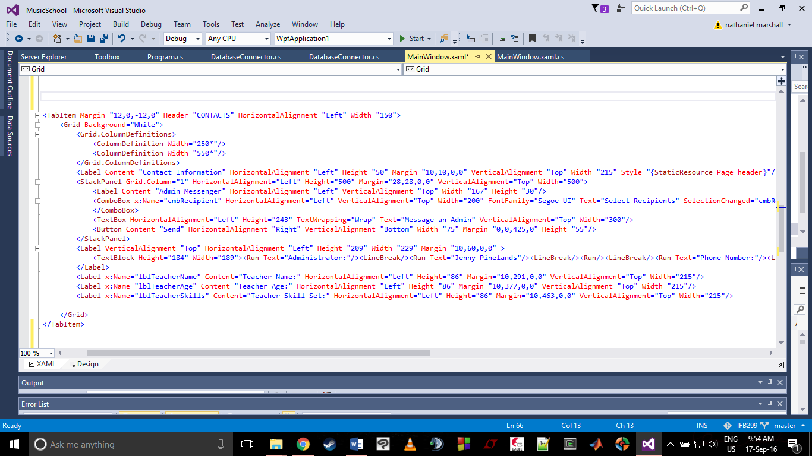

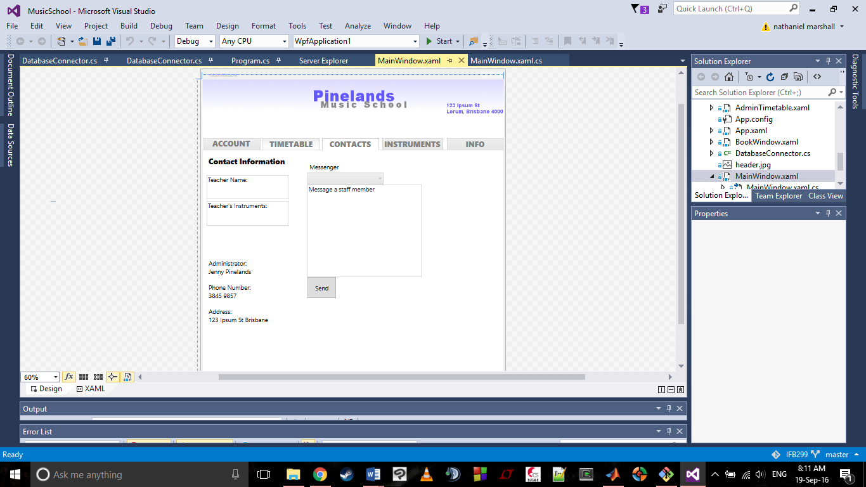

# Database Access Functions

In order to access the database, functions were created to enable access to retrieve information. I set up the code for retrieval from both the teachers and instruments tables, allowing for easy access of information.

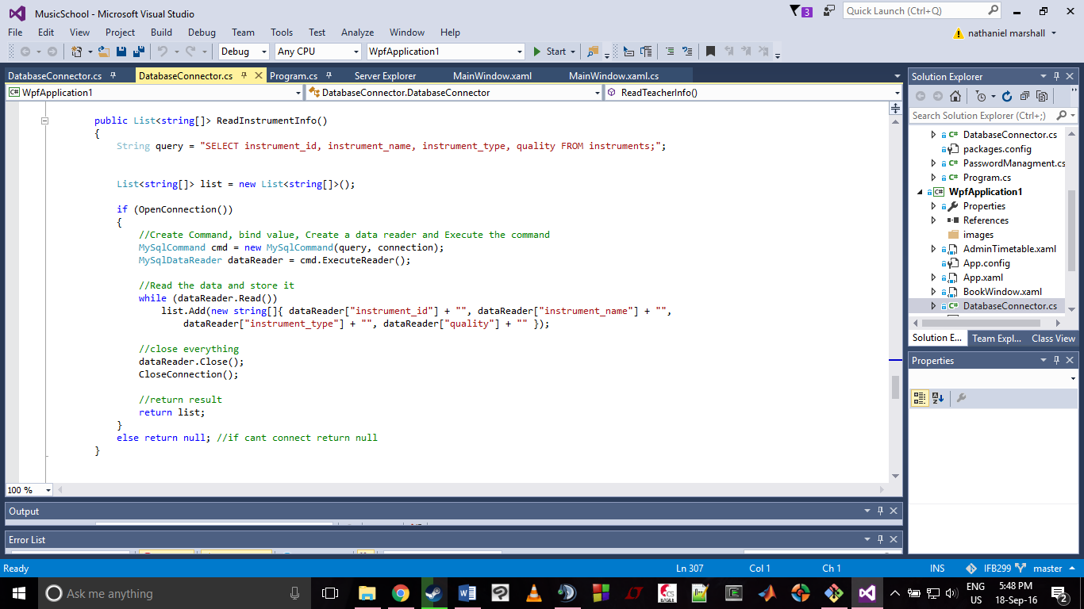

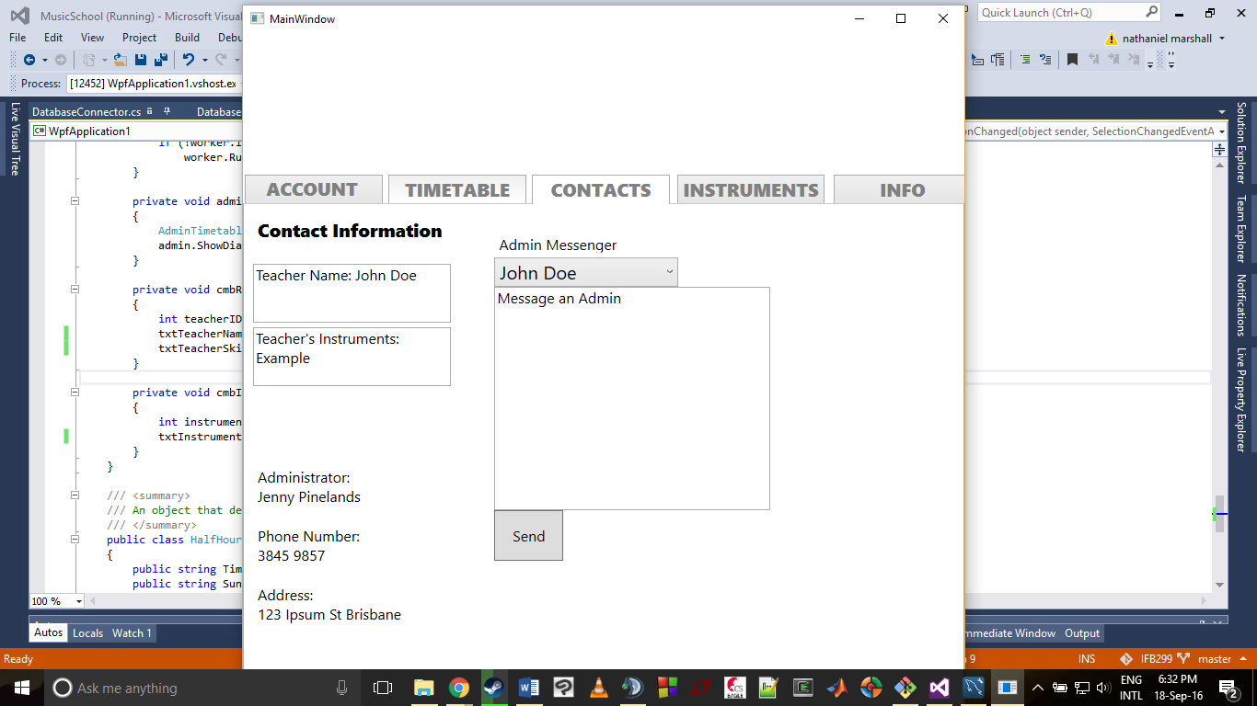

# Designed User Interfaces

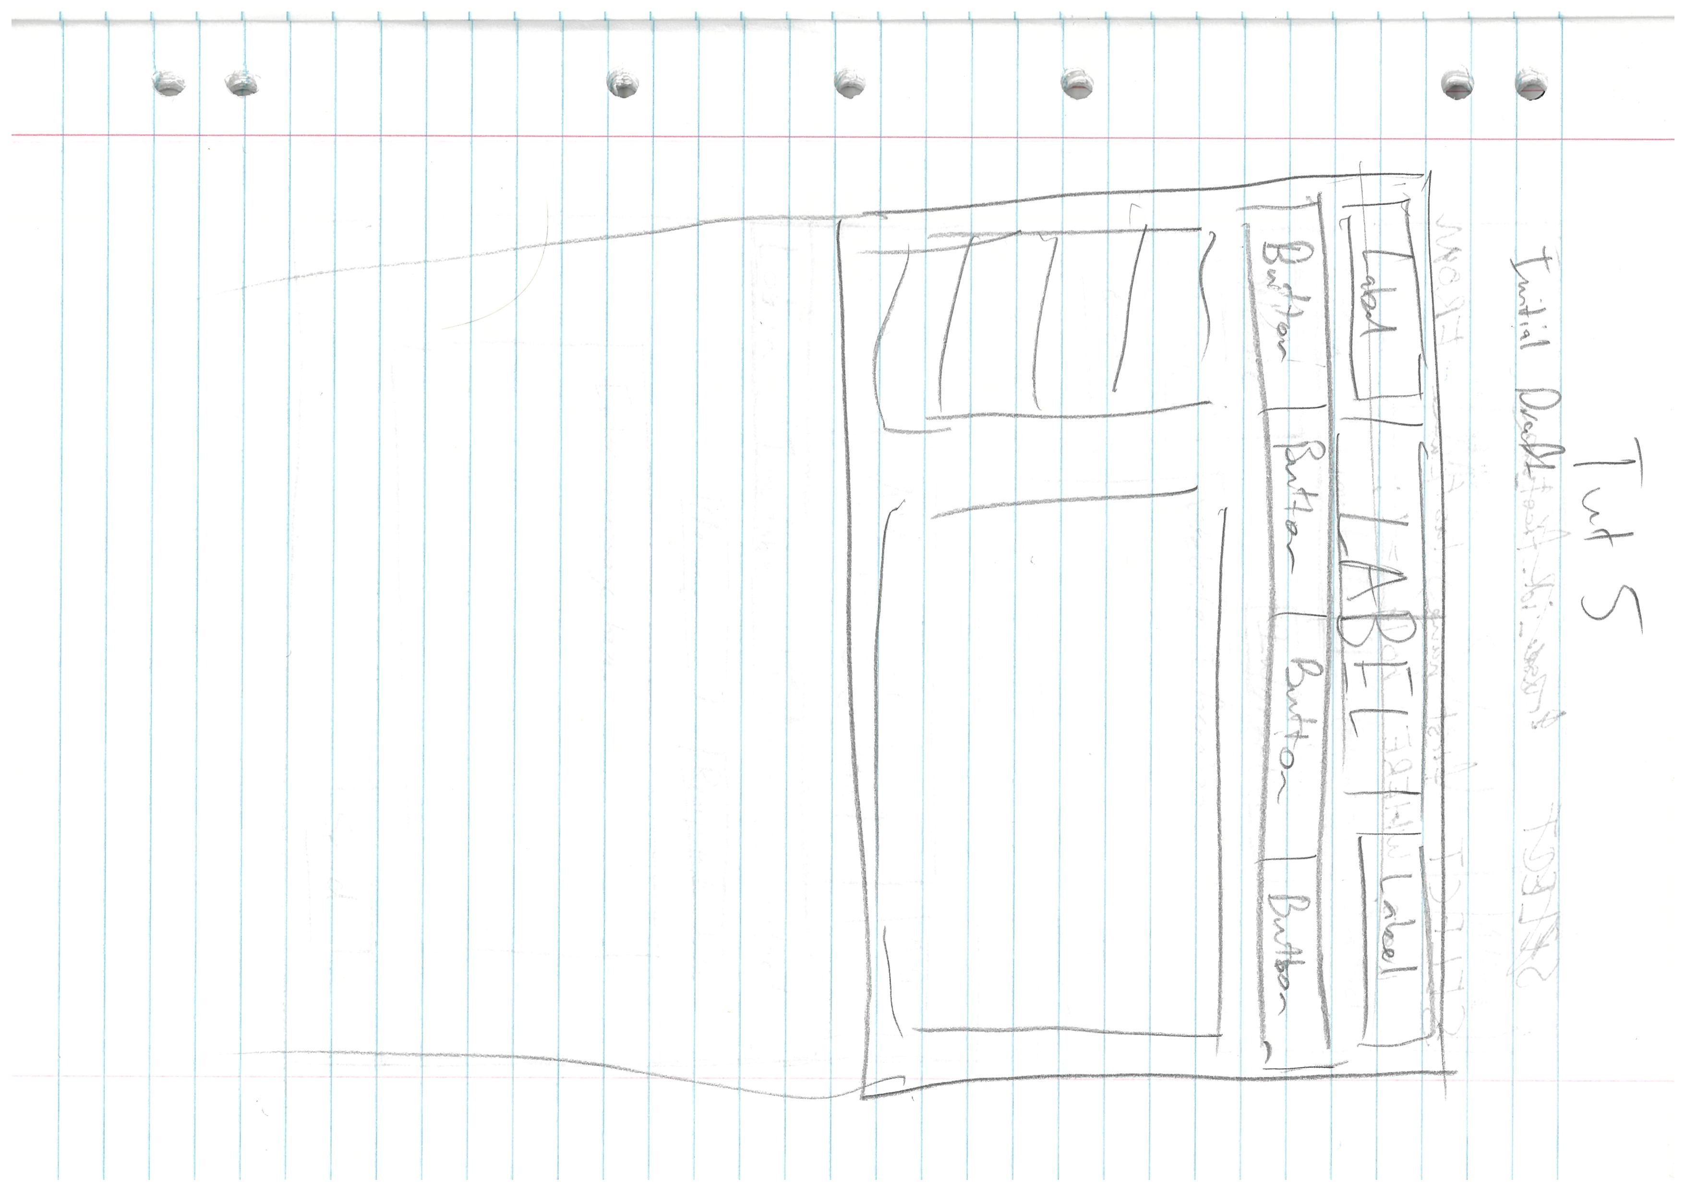Initially the client team provided a list of user stories, detailing the type of experience a user should have when accessing the application. This was used to create an on paper design of the desired application. The design was modelled to these user stories and was confirmed by the client team. The design process included client team refinements and resulted in a design accepted by both the client team and development team.

Initially a very rough design was drawn up to give a general idea of the style of layout that the development team wanted.

After some communication with the client team and feedback they had no issues with the design and allowed us to continue along with this style.

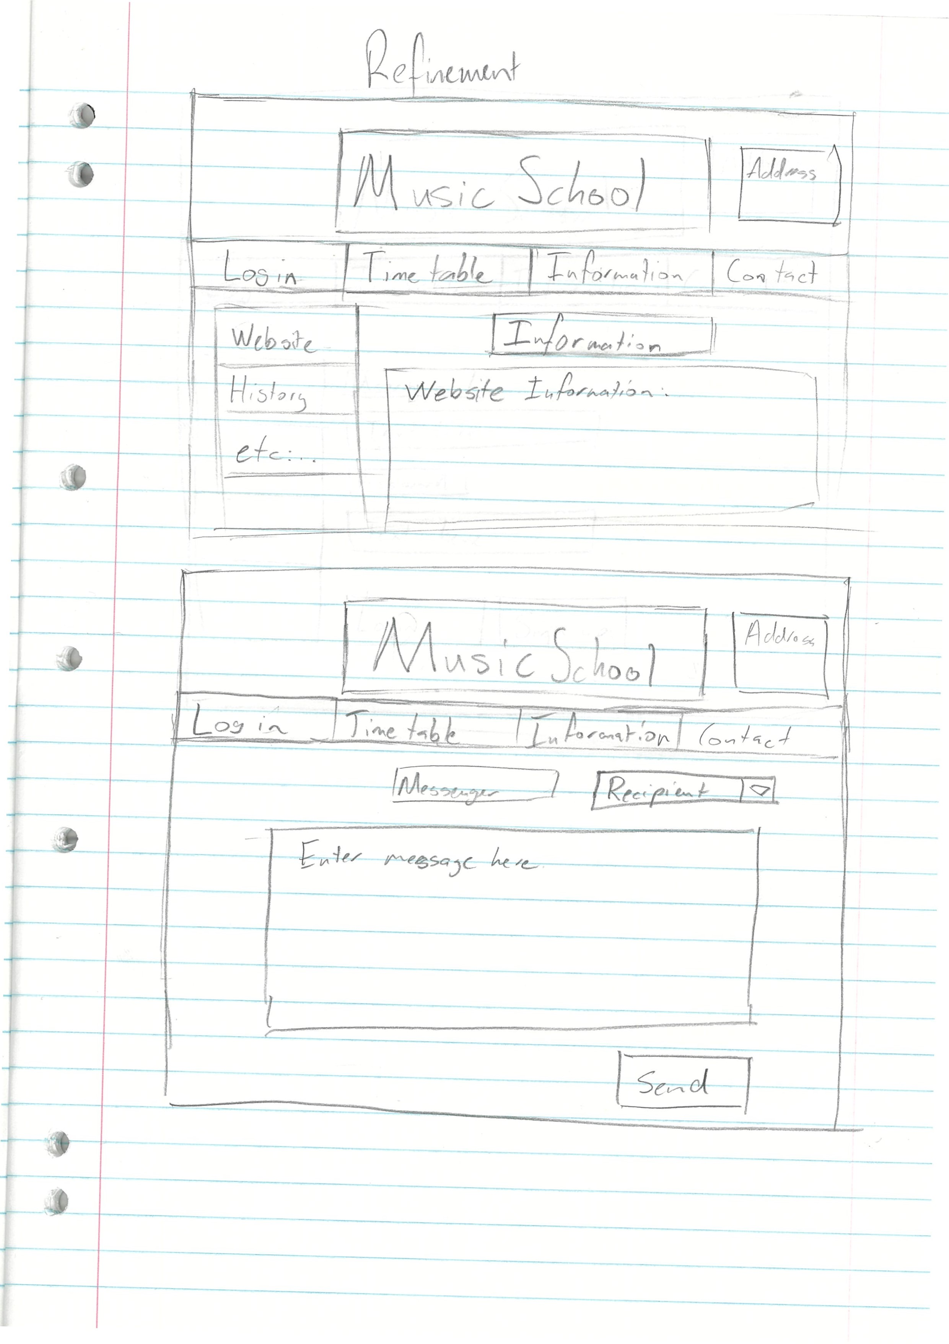This was then used as a base design to show how the specific tabs would be visually designed. Seen below are the initial paper designs for Information, Contact and Login.

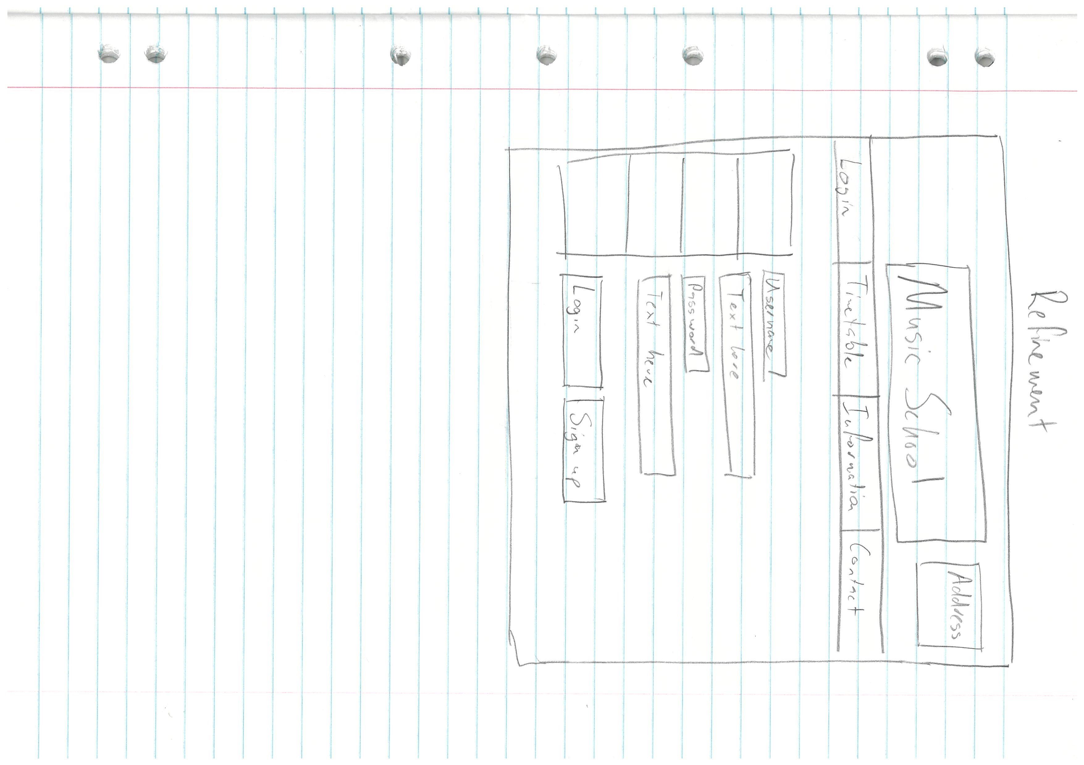Initial Design of Login: